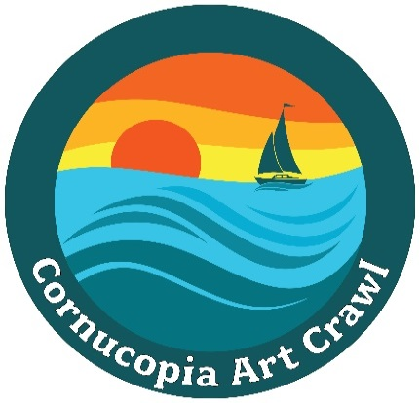
Announcing the
2025 Poster Contest
for the
21th Annual Cornucopia Art Crawl
September 6th-7th, 2025

The Cornucopia Art Crawl Poster
The Cornucopia Art Crawl Poster is a visual means to advertise our event. A copy of the poster will be widely distributed in the area and published in local print media. High quality copies will be available for sale prior to and at the event.

Submission Parameters:
- The preferred image should convey a strong sense of identification with the Cornucopia locality – its geography, beauty, people, heritage, history, and/or culture.
- The image must be an original work and can be rendered in any visual medium: a drawing, painting, photograph, print, computer-generated image, fiber art, etc.
- Image cannot have won any other regional contest.
- The image will additionally be judged on how well it works for a “for sale” poster and other promotional materials.
- One entry per artist submit original, unframed, in preferred size of “10 x 12”.
- All original artwork will be returned to artists after poster selection completed.

Copies of this form are available at the Community Center in an envelope attached to bulletin board in main room.

Entries due June 20th & 21th and must be turned into the Community Center between 10 a.m. & 2 p.m. or 7 p.m. & 8:30 p.m. on those dates. Artists will receive a receipt for the work. Judging will be completed by June 27th and the winner notified by June 30th. The winner of the contest will receive $100.

For more information, contact:
Nancy Lindgren at 612-210-1274, or by email at nnlindgren@comcast.net
Nancy Moye at 651-587-0017, or by email at njmigh@gmail.com

This project is supported in part by a grant from the Chequamegon Bay Arts Council and
the Wisconsin Arts Board, with State of Wisconsin Funding.

